Practical Exam   
Subject: WED201c  
Duration: 120 minutes

**Objectives:**

1. Create a Cascading Style Sheet (CSS) and a script file (js) and then link it to the HTML files. **(Without changing the html)**

2. Style the sheet using the properties color, background-color, text-align, text-transform, and/or display, …

3. Javascript is used to validate a form and change style property of p tags.

**Background:**

In this practical exam, you are going to use some files in the **Resource folder** to finish the exam.

**Before styling responsive.html page**

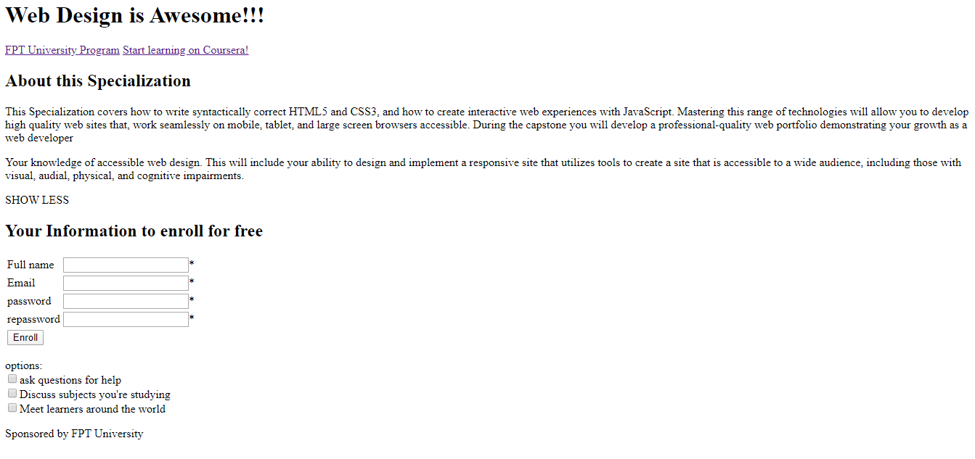

**After styling responsive.html page**

Template 1.png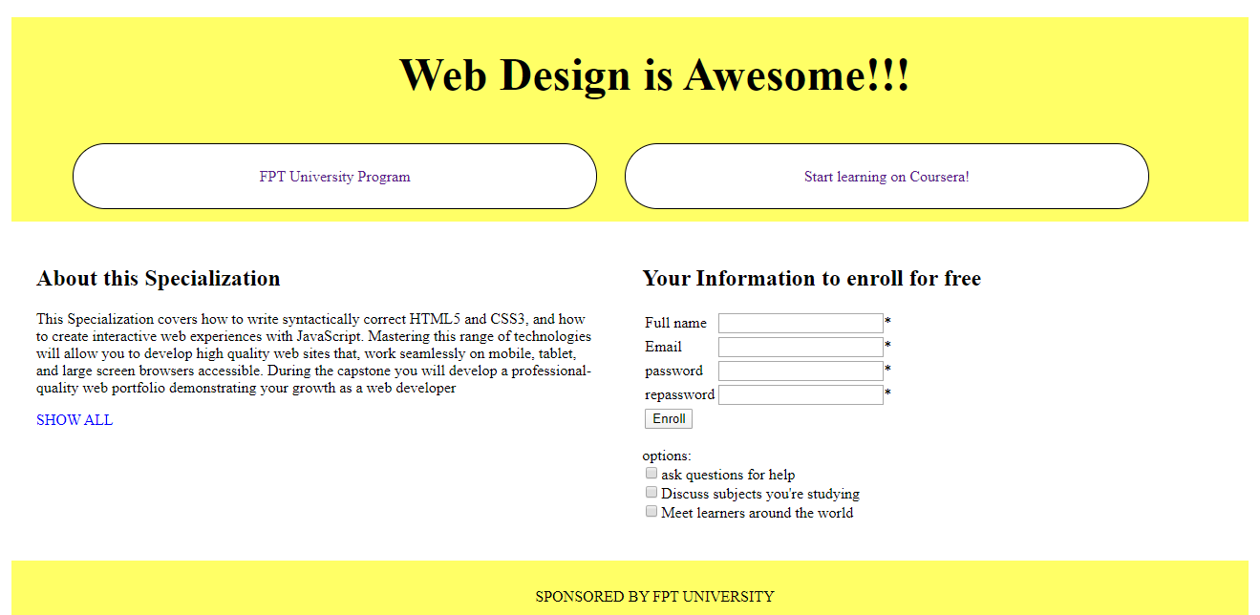

Click for showing more

**Template 2.png**

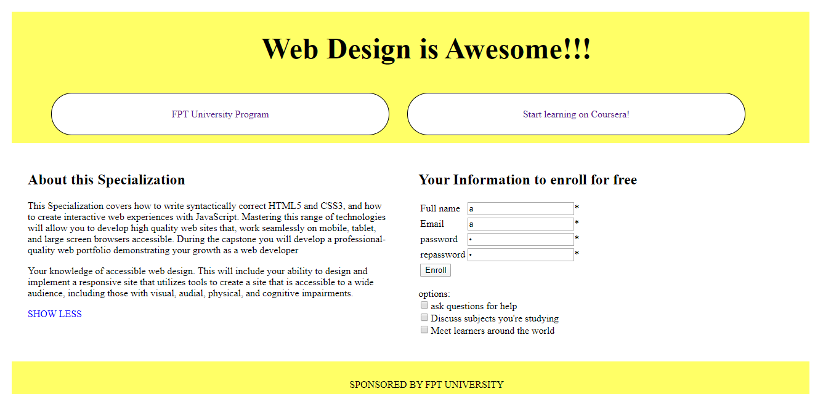

Click for showing less

**Requirements:**

1. Create a file called **responsive.css** and save it in the given **Resource folder.**
2. In file **responsive.css**, using the CSS properties to style page “responsive.html”. You can view the styled page in folder “**Template**” *(Hint: template 1.png and template2.png)*
3. Create a file called “**responsive.js**” and save it in the given **Resource folder.**
4. In file responsive.js, you must code some functions:
   1. Write a function **show()** to display/hide the paragraph (**id=”para2”)** and change the inner text of the paragraph (id=”para3”) when the user clicks on it. *(hint: template 1.png and template2.png)*
   2. Write a function **Enroll()** to validate a form.

Validate:

- Any fields are empty when clicking the button “Enroll”, the web page displays a message “please fill all fields” (condition 1)

- If the password and re password do not match, the web page displays a message “password/repassword is invalid” (condition 2)

- If condition 1 and condition 2 are correct and all options do not be checked, the web page displays a confirm message “would you like to choose options”. (Condition 3)

+ If the user chooses “No”, the web page displays a message “start leaning WED201c”

+ If the user chooses “OK”, the web page does nothing

***Example:***

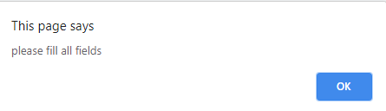

Click for validating form

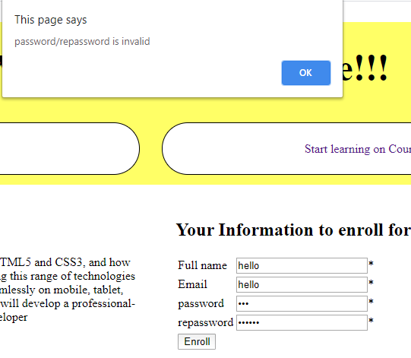

Click for validating form

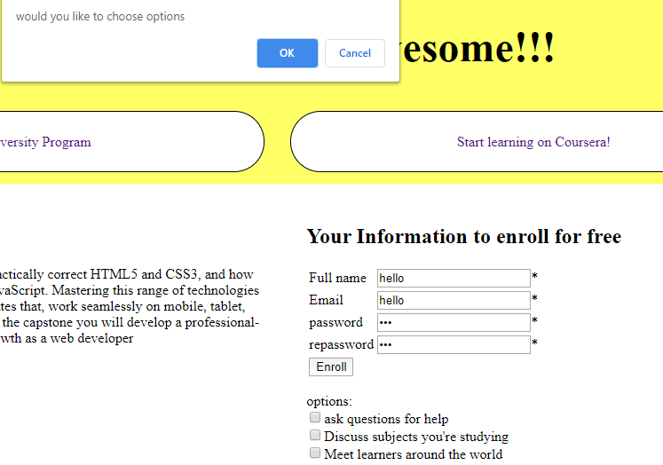

Click for validating form

1. When submitting your result, please submit the **whole folder** includes **all your files and sub-folders but not just only CSS file and JS file**.

**Evaluation:**

**CSS: [5 points]**

1. Header, footer, and section should be floated like the sample. [1.5 points]
2. Header and footer have background color [0.5 point]
3. the tag <h1> in header should be styled in center [0.5 point]
4. the tag <a> in the head should be styled:

* underline: none [0.5 point]
* text-align: center [0.5 point]
* have border [0.5 point]

1. The tag p (id=”rapa2”) should be hidden when the web page starts [0.5 point]
2. The tag p(id=”para3” has text color: blue [0.5 point]

**JavaScript: 5 points**

1. When the user clicks “SHOW ALL”, the function show() displays the tag p(id=”para2”) [0.5 point]

And change inner text in the tag (id=”para3”) to “SHOW LESS” [0.5 point]

1. When the user clicks “SHOW LESS”, the function show() hides the tag p(id=”para2”) [0.5 point]

And change inner text in the tag (id=”para3”) to “SHOW ALL” [0.5 point]

1. Students validate condition 1 correctly [1 point]
2. Students validate condition 2 correctly [1 point]
3. Students validate condition 3 correctly [1 point]

**Total: 10 points**

**(Students do not change the path of all files in Resource folder)**

The End